Assignment 4 Report

Part 1:

For this part the program reads in the file, first taking in values like the max and min x y and z values, and computing the average to be used for view location. Next it loops over reading in the amount of lines to read, reading those and storing them in a vector, then storing that vector in a vector. Once that is all done it sends the vertices to the vertex array in x y z format. The vertex array is then sent to the buffer, along with an index array which is just incremental. Finally it is drawn using a GL_LINE_STRIP in a for loop to make sure other lines don’t connect to the wrong lines.

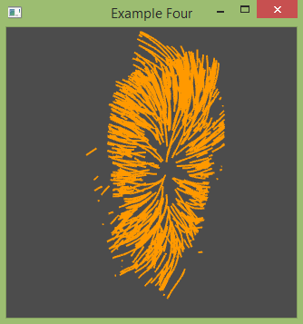

Part 2:

This part is mostly done, but the display is not showing up. But similar to part 1 it reads in the coordinates, but now instead of using that value now we make 4 other coordinates around it using cross products and stuff. This is done for each point and the larger amount of points are still stored the same way. The vertices array is built largely the same as well, albeit much larger this time. The index array is the most complicated. Essentially, it is making 8 triangles (4 rectangles) between 2 sets of 4 points to make a tube, to do this it groups up pairs of triangles which should be together and increases by a larger factor because of the larger groupings. Then finally, it is supposed to draw the triangles using the GL_TRIANGLES in the display function, but for some reason, there is nothing being displayed.